GGR272 Assignment 3

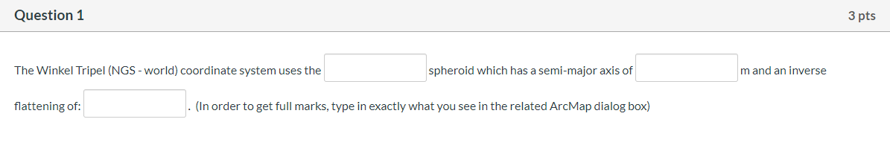

Spheroid: WGS_1984, Semimajor Axis: 6378137.0, Inverse Flattening: 298.257223563

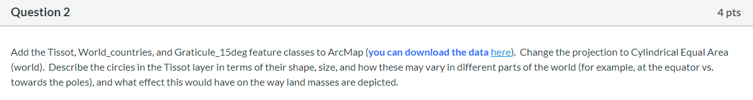

The circles appear to be perfectly round at the equator, and as they move towards the poles the circles become elongated in the horizontal direction. The size of the circles remain the same, but the shape changes. The map is equal area but is not conformal. This means that there is no distortion at the equator, but there is shape distortion at the poles which makes the countries appear shorter and wider, similar to the circles in the Tissot layer.

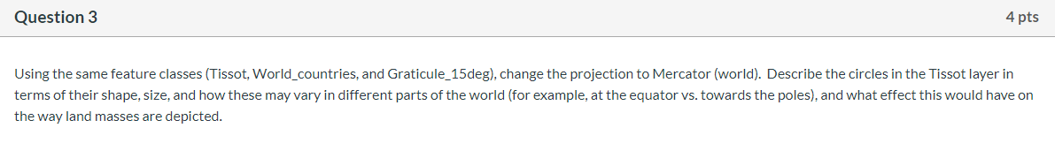

The circles are round and maintain their shape throughout, however their size increases as they move away from the equator and towards the poles. The map is not equal area but it is conformal. This means that land masses near the equator will appear smaller and those at the poles appear larger. For example, Greenland appears to be larger than the entire continent of Africa on this 2D map, but we know that is not true in real life.

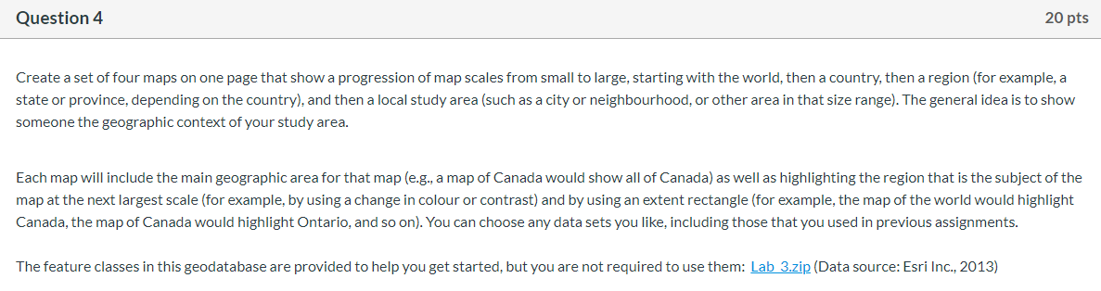

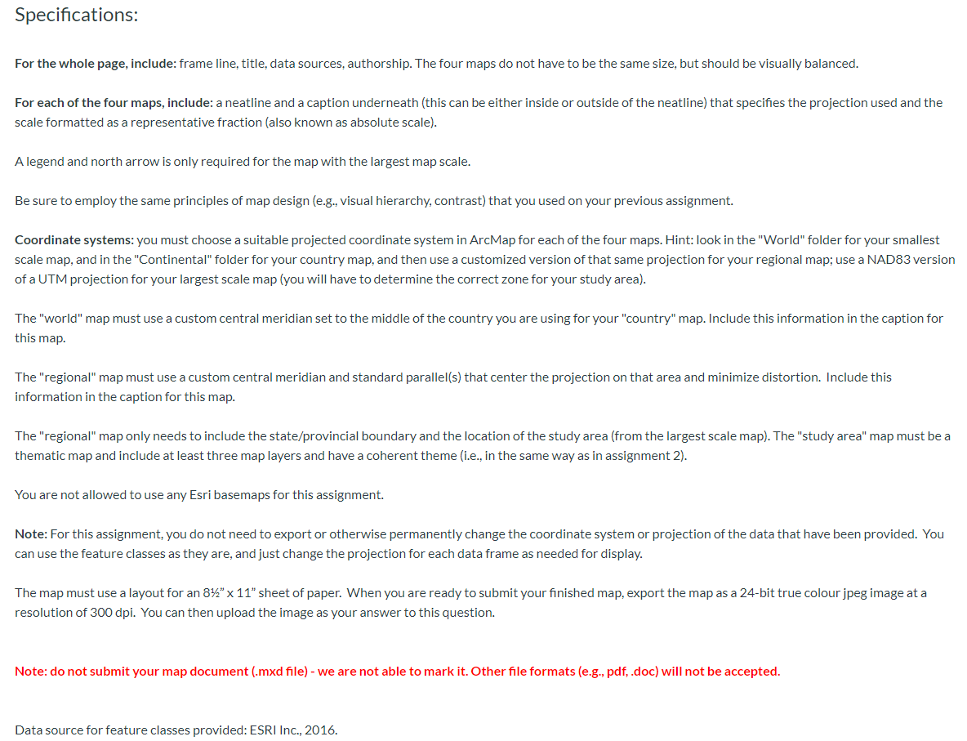

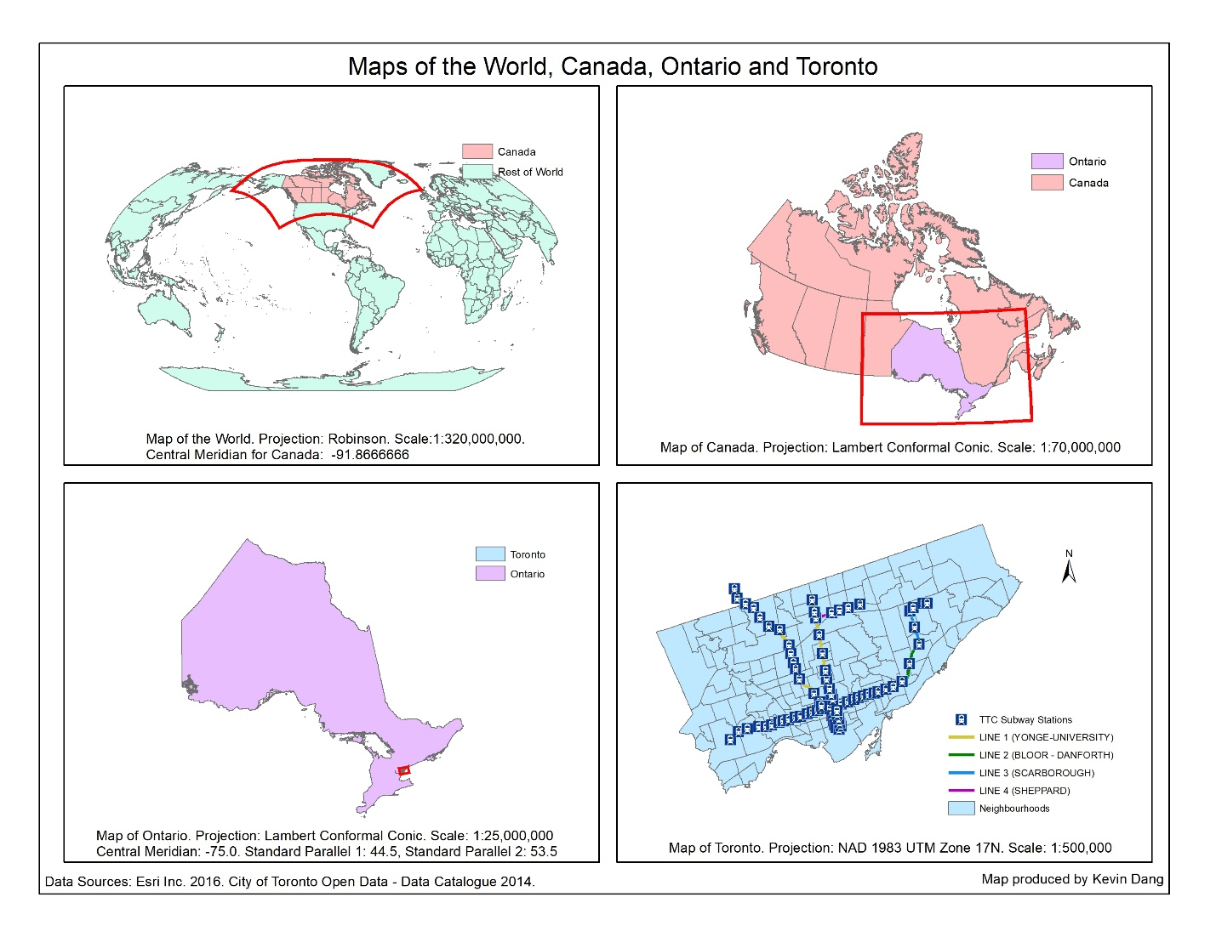



The projection I used for the world map is the Robinson projection. The reason I chose this projection is because it finds a very good balance between shape and area to avoid extreme distortions.



For my map of Canada, I used a Lambert Conformal Conic projection. It has a good relationship between direction and shape for mid latitude regions, and it is the most common map projection used at Statistics Canada for maps of Canada.